Home Products Services About Us Contact Us Affiliates Buy Now

MindSightsTM



MindSights

Tacit Knowledge Capture

Application Developer

Navigation: Click on Blue Links
Go To Main Menu

Instructions
You are building a hypertext application that captures your knowledge. The goal is for this application to guide others to do what are doing. Simply put yourself in the role of a mentor/coach and do the following
- Identify the work task you want to develop a knowledge capture application
- Identify all the work steps within the work task.
- Identify all and the questions you ask for each step
- Identify all the tools you use for each step.
- Complete the hypertext application below. Go There Now

Note: If you need set “One Click” for Hyperlinking: The MS Word default for using hyperlinks is “Use CTRL + Click to follow hyperlink.” So, if the “hand icon” is not showing, hold the [Ctrl] key down while clicking. Note: If you want to change to one click do the following:

If you are running Word in Windows XT look at the menu bar and: 1. click on Tools; 2. then click on Options; 3. then click on Edit; 4. then click "off" the check box that says [Use CNTL + click to follow hyperlink].
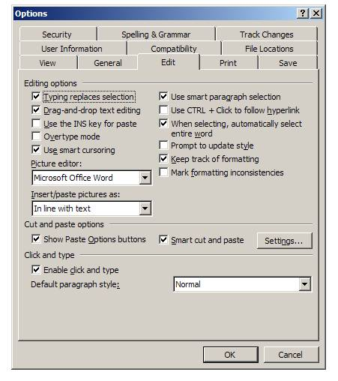

If you are using MS Word in Vista: 1. click on the Office Button  in the upper left. 2. Click on Word Options (at the bottom). 3. Click on the Advanced link and 4. then click "off" the check box that says [Use CNTL + click to follow hyperlink]. See picture.

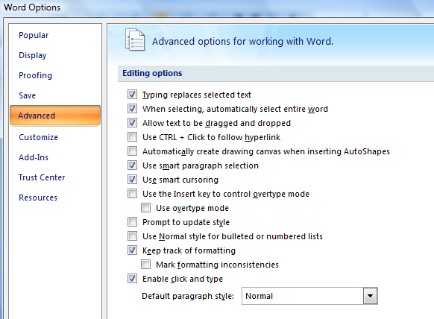

How to create a hyperlink

Step | Description | Example
1 | Paste the tool you want to use under the Tool (Thinklets) box. | Use the Test Tool Name below or paste your own.
2 | With the cursor, highlight the entire name or a single word. | Highlight the word Tool
3 | With the name highlighted, click Insert:Bookmark from the MS Word toolbar. | Do it
4 | Type in a bookmark name of your choice and click OK | Use testname1 or your own name.
5. | Type the name of tool under list of tools. | Type 1. Test Tool Name
6 | Highlight that name. | Do it
7 | Click Insert: Hyperlink | Do it
8 | Click “Place in this document” | Do it
9 | Scroll until you find the bookname name | Find testname1 or your own name.
10 | Click on the bookmark name. Your link will turn blue with and underline. | It should look like this  1. Test Tool Name
11 | Your link is now active. Click on it and you will (link to) that tool. | The cursor will be in front of the word tool. Test Tool Name

Tools (Thinklets)
Paste the tool(s) below that will help the team better think about this task. List the name of the tool here and create a hyperlink or simply scroll to it. See how to create a hyperlink.
List of Tools
1. Test Tool Name

Test Tool Name
Why Use It
….

How to Use It
….

Your Company Name
(Organization Name)

[Enter Application Name Here]

Menu | T1 | T2 | T3 | T4 | T5 | T6 | T7 | T8 | T9 | T10

[Application Name here] (instructions)
Main Menu

Application Purpose
(Describe the overall purpose of your application)

Steps/Tasks | Task Name (Enter your application’s tasks by name, in sequence if possible)
Step/Task 1
Step/Task 2
Step/Task 3
Step/Task 4
Step/Task 5
Step/Task 6
Step/Task 7
Step/Task 8
Step/Task 9
Step/Task 10

Other Relevant Information

Menu | T1 | T2 | T3 | T4 | T5 | T6 | T7 | T8 | T9 | T10

Task #1 [enter name here]

Thinking Task Description
Task Purpose:

Task Flow: If the following happens Go To Task [ ]

Key Questions to Ask
List the questions you ask and actions you take for this task.

Question to Ask
Expected Answer | Unexpected Answer
Action | Action

Question to Ask
Expected Answer | Unexpected Answer
Action | Action
(Copy and paste if more questions are asked)

Recommended Tools to Use
Click and paste the tools you use to help you think better about this step/task. List tool name below.

Task 1 Tool 1 | Name:
Task 1 Tool 2 | Name:
Step/Task 1 Tool 1

Menu | Return | Task 1 Tool 1 | Task 1 Tool 2

Paste your tool here

Step/Task 1 Tool 2

Menu | Return | Task 1 Tool 1 | Task 1 Tool 2

Paste your tool here

Menu | T1 | T2 | T3 | T4 | T5 | T6 | T7 | T8 | T9 | T10

Task #2 [name here]

Thinking Task Description
Task Purpose:

Task Flow: If the following happens Go To Task [ ]

Key Questions to Ask
List the questions you ask and actions you take for this task.

Question to Ask
Expected Answer | Unexpected Answer
Action | Action

Question to Ask
Expected Answer | Unexpected Answer
Action | Action
(Copy and paste if more questions are asked)

Recommended Tools to Use
Click and paste the tools you use to help you think better about this step/task. List tool name below.

Task 2 Tool 1 | Name:
Task 2 Tool 2 | Name:

Step/Task 2 Tool 1

Menu | Return | Task 2 Tool 1 | Task 2 Tool 2

Paste your tool here

Step/Task 2 Tool 2

Menu | Return | Task 2 Tool 1 | Task 2 Tool 2

Paste your tool here

Menu | T1 | T2 | T3 | T4 | T5 | T6 | T7 | T8 | T9 | T10

Task #3 [name here]

Thinking Task Description
Task Purpose:

Task Flow: If the following happens Go To Task [ ]

Key Questions to Ask
List the questions you ask and actions you take for this task.

Question to Ask
Expected Answer | Unexpected Answer
Action | Action

Question to Ask
Expected Answer | Unexpected Answer
Action | Action
(Copy and paste if more questions are asked)

Recommended Tools to Use
Click and paste the tools you use to help you think better about this step/task. List tool name below.

Task 3 Tool 1 | Name:
Task 3 Tool 2 | Name:

Step/Task 3 Tool 1

Menu | Return | Task 3 Tool 1 | Task 3 Tool 2

Paste your tool here

Step/Task 3 Tool 2

Menu | Return | Task 3 Tool 1 | Task 3 Tool 2

Paste your tool here

Menu | T1 | T2 | T3 | T4 | T5 | T6 | T7 | T8 | T9 | T10

Task #4 [name here]

Thinking Task Description
Task Purpose:

Task Flow: If the following happens Go To Task [ ]

Key Questions to Ask
List the questions you ask and actions you take for this task.

Question to Ask
Expected Answer | Unexpected Answer
Action | Action

Question to Ask
Expected Answer | Unexpected Answer
Action | Action
(Copy and paste if more questions are asked)

Recommended Tools to Use
Click and paste the tools you use to help you think better about this step/task. List tool name below.

Task 4 Tool 1 | Name:
Task 4 Tool 2 | Name:

Step/Task 4 Tool 1

Menu | Return | Task 4 Tool 1 | Task 4 Tool 2

Paste your tool here

Step/Task 4 Tool 2

Menu | Return | Task 4 Tool 1 | Task 4 Tool 2

Paste your tool here

Menu | T1 | T2 | T3 | T4 | T5 | T6 | T7 | T8 | T9 | T10

Task #5 [name here]

Thinking Task Description
Task Purpose:

Task Flow: If the following happens Go To Task [ ]

Key Questions to Ask
List the questions you ask and actions you take for this task.

Question to Ask
Expected Answer | Unexpected Answer
Action | Action

Question to Ask
Expected Answer | Unexpected Answer
Action | Action
(Copy and paste if more questions are asked)

Recommended Tools to Use
Click and paste the tools you use to help you think better about this step/task. List tool name below.

Task 5 Tool 1 | Name:
Task 5 Tool 2 | Name:

Step/Task 5 Tool 1

Menu | Return | Task 5 Tool 1 | Task 5 Tool 2

Paste your tool here

Step/Task 5 Tool 2

Menu | Return | Task 5 Tool 1 | Task 5 Tool 2

Paste your tool here

Menu | T1 | T2 | T3 | T4 | T5 | T6 | T7 | T8 | T9 | T10

Task #6 [name here]

Thinking Task Description
Task Purpose:

Task Flow: If the following happens Go To Task [ ]

Key Questions to Ask
List the questions you ask and actions you take for this task.

Question to Ask
Expected Answer | Unexpected Answer
Action | Action

Question to Ask
Expected Answer | Unexpected Answer
Action | Action
(Copy and paste if more questions are asked)

Recommended Tools to Use
Click and paste the tools you use to help you think better about this step/task. List tool name below.

Task 6 Tool 1 | Name:
Task 6 Tool 2 | Name:

Step/Task 6 Tool 1

Menu | Return | Task 6 Tool 1 | Task 6 Tool 2

Paste your tool here

Step/Task 6 Tool 2

Menu | Return | Task 6 Tool 1 | Task 6 Tool 2

Paste your tool here

Menu | T1 | T2 | T3 | T4 | T5 | T6 | T7 | T8 | T9 | T10

Task #7 [name here]

Thinking Task Description
Task Purpose:

Task Flow: If the following happens Go To Task [ ]

Key Questions to Ask
List the questions you ask and actions you take for this task.

Question to Ask
Expected Answer | Unexpected Answer
Action | Action

Question to Ask
Expected Answer | Unexpected Answer
Action | Action
(Copy and paste if more questions are asked)

Recommended Tools to Use
Click and paste the tools you use to help you think better about this step/task. List tool name below.

Task 7 Tool 1 | Name:
Task 7 Tool 2 | Name:

Step/Task 7 Tool 1

Menu | Return | Task 7 Tool 1 | Task 7 Tool 2

Paste your tool here

Step/Task 7 Tool 2

Menu | Return | Task 7 Tool 1 | Task 7 Tool 2

Paste your tool here

Menu | T1 | T2 | T3 | T4 | T5 | T6 | T7 | T8 | T9 | T10

Task #8 [name here]

Thinking Task Description
Task Purpose:

Task Flow: If the following happens Go To Task [ ]

Key Questions to Ask
List the questions you ask and actions you take for this task.

Question to Ask
Expected Answer | Unexpected Answer
Action | Action

Question to Ask
Expected Answer | Unexpected Answer
Action | Action
(Copy and paste if more questions are asked)

Recommended Tools to Use
Click and paste the tools you use to help you think better about this step/task. List tool name below.

Task 8 Tool 1 | Name:
Task 8 Tool 2 | Name:

Step/Task 8 Tool 1

Menu | Return | Task 8 Tool 1 | Task 8 Tool 2

Paste your tool here

Step/Task 8 Tool 2

Menu | Return | Task 8 Tool 1 | Task 8 Tool 2

Paste your tool here

Menu | T1 | T2 | T3 | T4 | T5 | T6 | T7 | T8 | T9 | T10

Task #9 [name here]

Thinking Task Description
Task Purpose:

Task Flow: If the following happens Go To Task [ ]

Key Questions to Ask
List the questions you ask and actions you take for this task.

Question to Ask
Expected Answer | Unexpected Answer
Action | Action

Question to Ask
Expected Answer | Unexpected Answer
Action | Action
(Copy and paste if more questions are asked)

Recommended Tools to Use
Click and paste the tools you use to help you think better about this step/task. List tool name below.

Task 9 Tool 1 | Name:
Task 9 Tool 2 | Name:

Step/Task 9 Tool 1

Menu | Return | Task 9 Tool 1 | Task 9 Tool 2

Paste your tool here

Step/Task 9 Tool 2

Menu | Return | Task 9 Tool 1 | Task 9 Tool 2

Paste your tool here

Menu | T1 | T2 | T3 | T4 | T5 | T6 | T7 | T8 | T9 | T10

Task #10 [name here]

Thinking Task Description
Task Purpose:

Task Flow: If the following happens Go To Task [ ]

Key Questions to Ask
List the questions you ask and actions you take for this task.

Question to Ask
Expected Answer | Unexpected Answer
Action | Action

Question to Ask
Expected Answer | Unexpected Answer
Action | Action
(Copy and paste if more questions are asked)

Recommended Tools to Use
Click and paste the tools you use to help you think better about this step/task. List tool name below.

Task 10 Tool 1 | Name:
Task 10 Tool 2 | Name:

Step/Task 10 Tool 1

Menu | Return | Task 10 Tool 1 | Task 10 Tool 2

Paste your tool here

Step/Task 10 Tool 2

Menu | Return | Task 10 Tool 1 | Task 10 Tool 2

Paste your tool here

Copyright © Nth Degree Software, Inc. dj@nthdegreesoft.com - Home

